SUPPORT & RESISTANCE TRADE ANALYSIS REPORT

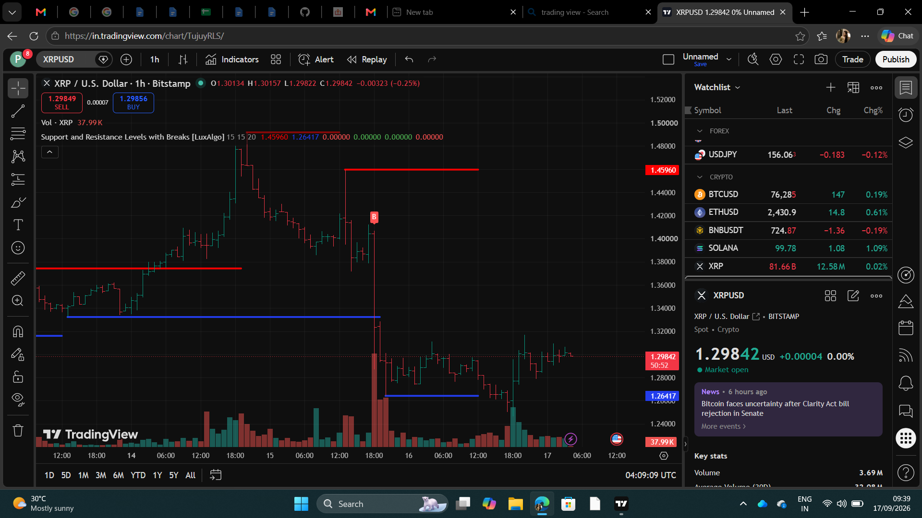

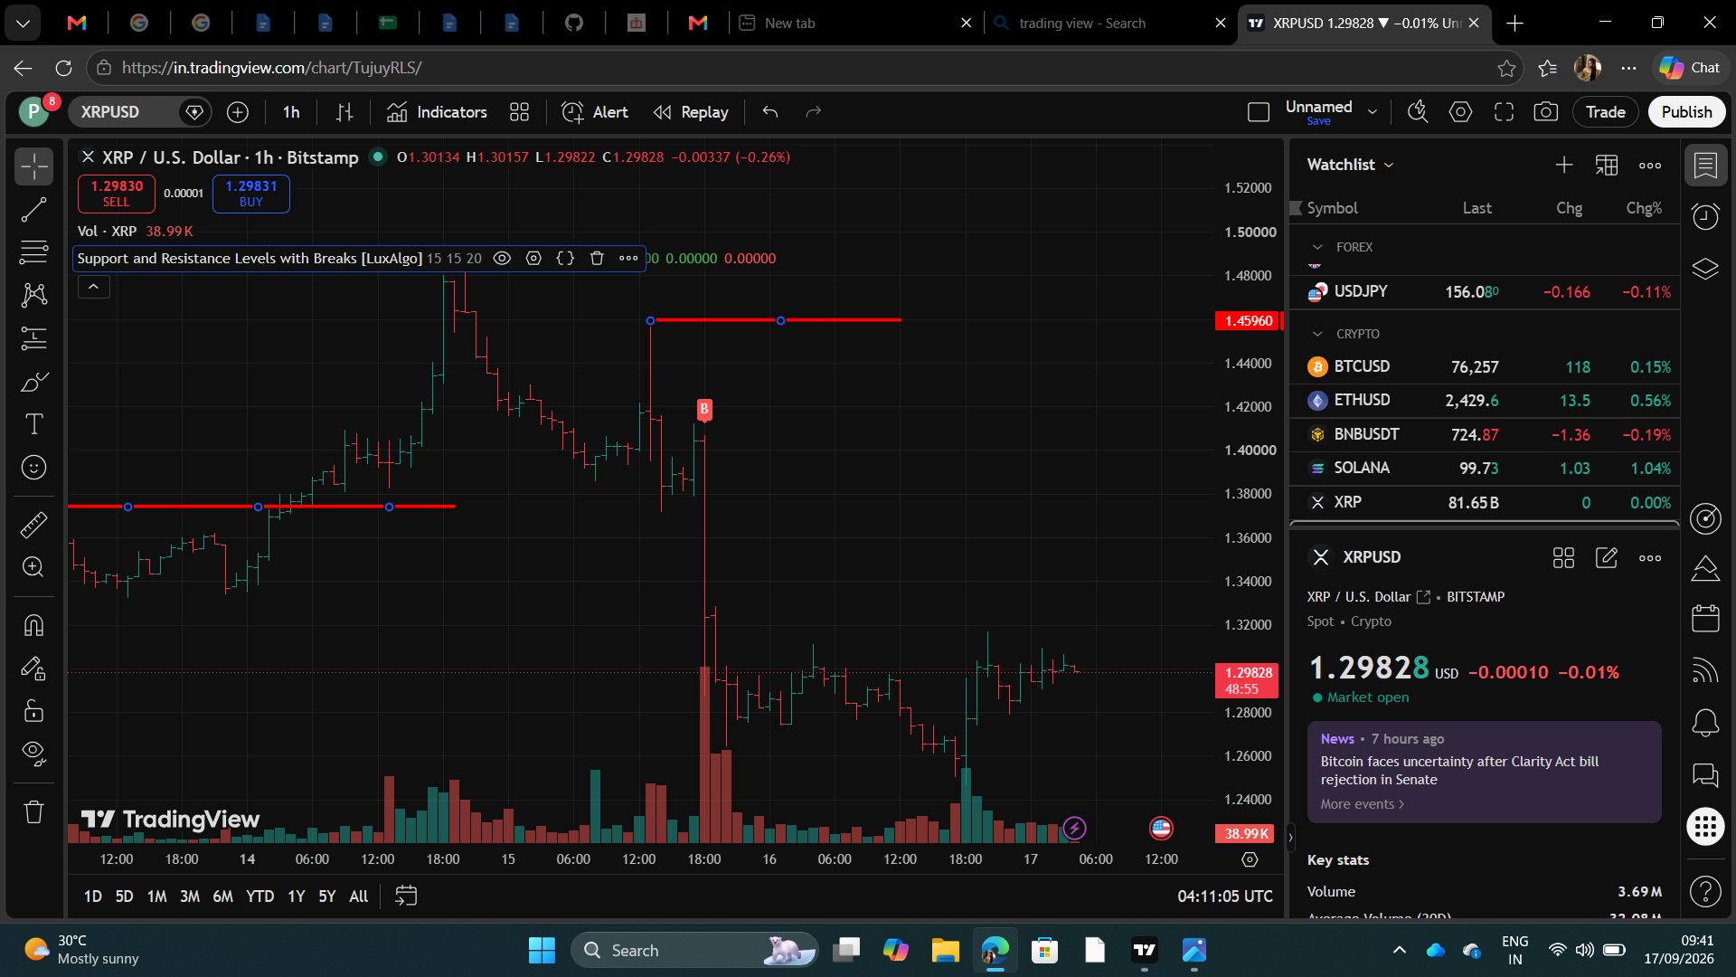

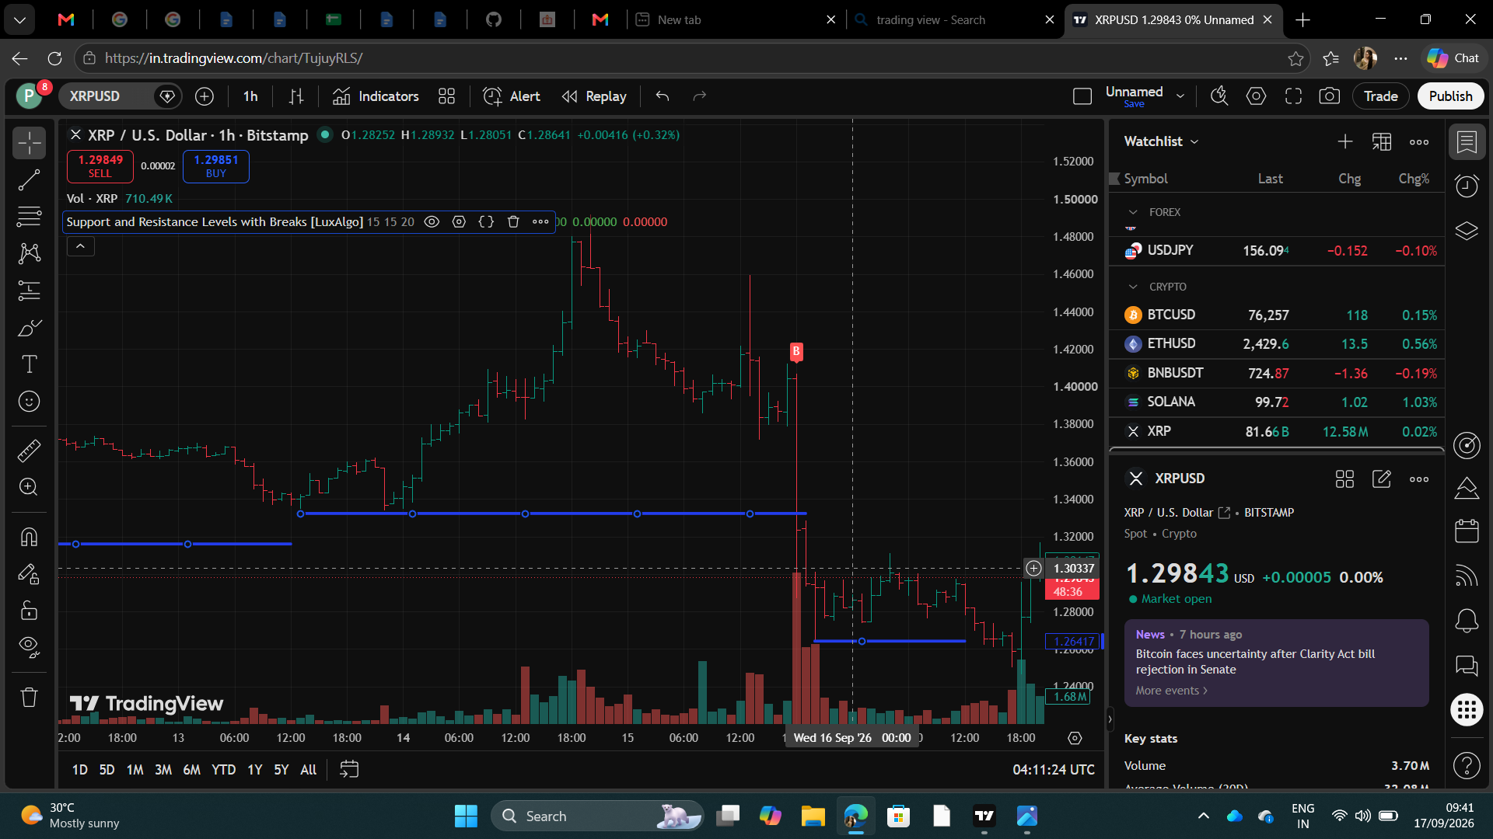

SUPPORT & RESISTANCE TRADE ANALYSIS REPORT

CHART ANALYSIS

PARTICULAR | OBSERVATION
ASSET NAME | XRP
SYMBOL | XRPUSD
TIMEFRAME | 1 HOUR (1H)
SUPPORT LEVEL | 1.45(APPROX)
RESISTANCE LEVEL | 1.26(APPROX)
CURRENT PRICE POSITION (NEAR SUPPORT/ NEAR RESISTANCE /BETWEEN LEVELS ) | NEAR SUPPORT

TRADING DECISION

PARTICULAR | OBSERVATION
TRADE EXECUTED | YES
TRADE TYPE (LONG / SHORT / NO TRADE) | LONG
REASON FOR TRADING DECISION | THE TRADE WAS INITIATED BECAUSE THE ASSET PRICE IS NEAR AN ESTABLISHED SUPPORT LEVEL, SIGNALING A POTENTIAL UPWARD REVERSAL.

TRADE DETAILS

PARTICULAR | OBSERVATION
ENTRY PRICE | 64,146
EXIT PRICE | 76,428
REALIZED PROFIT/LOSS | +19.18%
TRADE OUTCOME (PROFIT / LOSS) | PROFIT

